Basic R Looping program and if statements:

I am just trying to write some basic loops in R and looks like this is great to use. I created a very simple function print.loop.function which is taking two parameters and then it is looping till count reached. Then I am just checking modular division by if statement and writing gold class if it is even and writing silver class if it is odd. Below is the program and output.

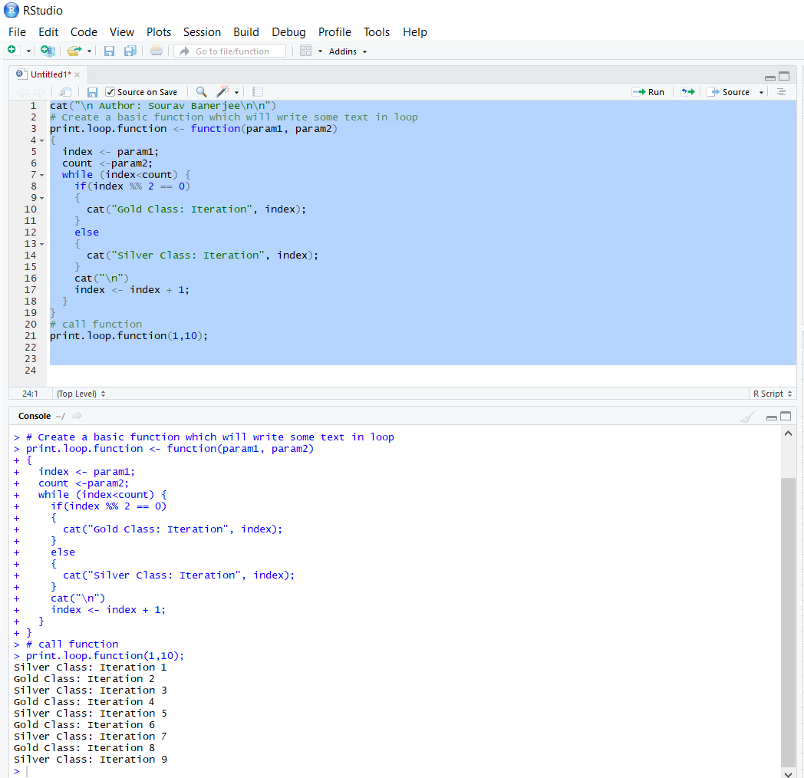

Get data from SQL Table:

I created a basic mysql table “sample”.

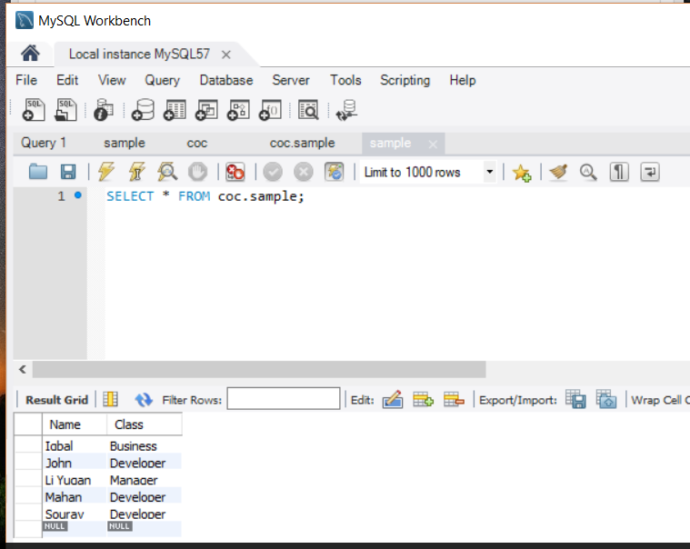

Then I created a odbc data source entry in system dsn.

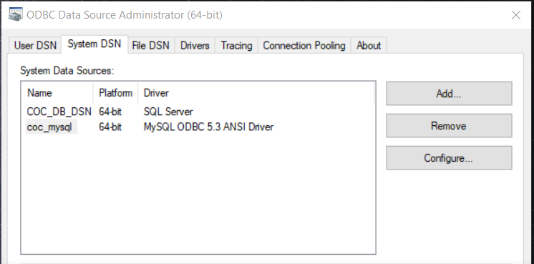

Now I installed R studio and open a new R file. And connected the odbc data source from the R script. Then I just executed a basic select query to see the data from sample table.

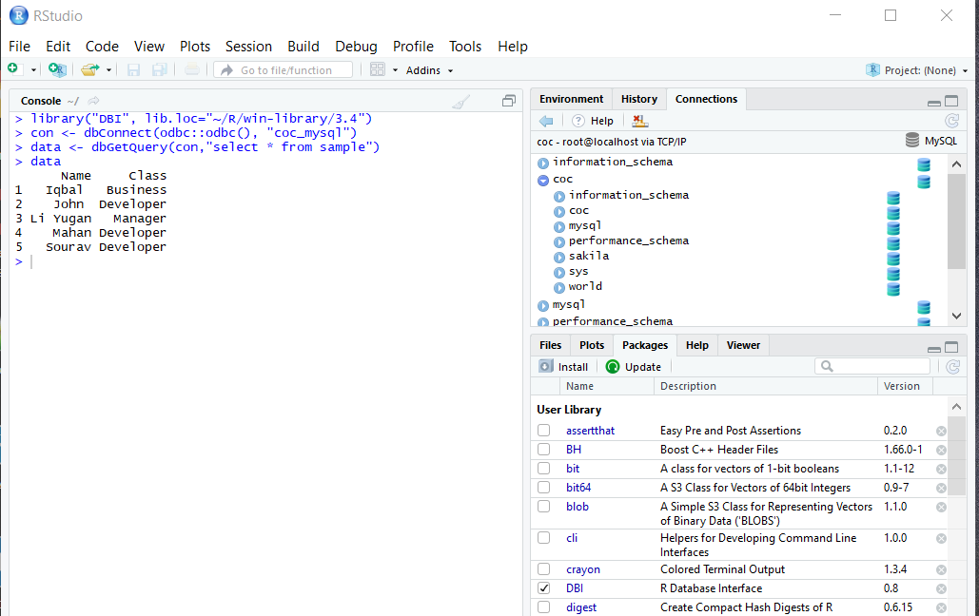

Set / Get working directory from R studio and Write dataset in txt file:

